An advisory commission of the Coastal Protection and Restoration Authority
cOASTAL LOUISIANA LEVEE CONSORTIUM

Amite River Basin Drainage and Water Conservation District

Atchafalaya Basin Levee District

Office of the Governor-Coastal Activities

Chenier Plain Coastal Restoration & Protection Authority

Grand Isle Independent Levee District

Iberia Parish Levee District

Jefferson Davis Parish Government

Lafitte Area Independent Levee District

Lafourche Basin Levee District

Non-Flood Protection Asset Management Authority

North Lafourche Conservation, Levee and Drainage District

Plaquemines Parish Government

Pontchartrain Levee District

The Sewerage and Water Board of New Orleans

South Lafourche Levee District

Southeast Louisiana Flood Protection Authority—East

Southeast Louisiana Flood Protection Authority—West

St. Mary Levee District

St. Tammany Levee District

Terrebonne Levee and Conservation District

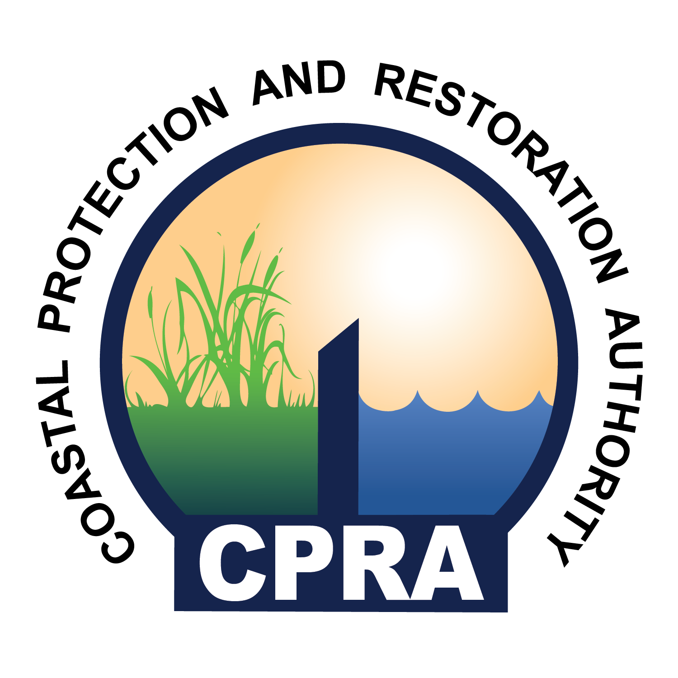

Rev: 03.0919.2018

CPRA Conference Room 401
150 Terrace Avenue
Baton Rouge, LA 70802

Thursday, September 20, 2018
9:30 A.M. – 11:30 A.M.

***All visitors must park in the CPRA Visitor Parking lot on Terrace Ave. If you have any questions about where to park, please contact Elaine at 225-342-7308.***

- Call to Order – Windell Curole
- Roll Call
- Approval of Agenda
- Approval of Minutes
- The Comite Diversion Canal Project, Dietmar Rietschier
- Performance of earthen levees for Hurricane Katrina, Windell Curole
- Standards for earthen levees, Windell Curole
- 408 Permissions
- NFIP, Dwayne Bourgeois
- State Legislation, Reggie Dupre and Dwayne Bourgeois
- Public Comment
- Adjourn

